|  |  |  |  |  |  |  |
| --- | --- | --- | --- | --- | --- | --- |
|  | | | | | | |
|  | | Smart Drop: A Real-Time Soil Monitoring Irrigation System | | |  | |
|  |  | | | | |  |
|  | | |  |  | | |
|  | | | STUDENT’SNAMESKolli Sreeram SaiSuchit ReddiMukku SohanMedikonda B V Sai Praveen ReddyAkshat PuniaAkshay VeeragandhamGroup No.11—EED308: Embedded Systems—Dr. Rohit Singh |  | | |

**TABLE OF CONTENTS**

Smart Drop: A Real-Time Soil Monitoring Drip Irrigation System 1

ABSTRACT 3

COMPONENTS 3

WORKING CIRCUIT 5

WORKING 6

CODE 7

BENEFITS 8

CHALLENGES 9

FUTURE ITERATIONS 9

CONCLUSION 9

REFERENCE 10

## ABSTRACT

The proposed project aims to develop a Wireless Real-Time Soil Monitoring Irrigation System using STM32 microcontroller and sensors. The system includes a soil moisture sensor that provides moisture data and controls the irrigation system using a stepper motor. The system also includes a rain sensor to predict rainfall and adjust the irrigation accordingly. The main objective of this project is to design an efficient and cost-effective system that can maintain the optimal moisture level in the soil and save water by controlling the irrigation system based on real-time soil and weather conditions. This project involves designing and programming the STM32 microcontroller, interfacing the sensors with the microcontroller, and assembling the hardware components. The proposed system will offer several benefits, including reduced water usage, improved crop yield, and increased efficiency in agricultural practices.

## COMPONENTS

1. **STM 32 BOARD(STM32F303RE)**

The STM32F303xE family is based on the high-performance ARMCortex-M4 32-bit RISC (reduced instruction set computer) core with FPU (Floating point unit) operating at a frequency of 72 MHz offer a large number of serial and parallel communication peripherals which can be interfaced with all kinds of electronic components.

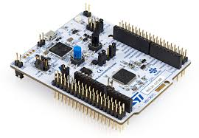

1. **SOIL MOISTURE SENSOR**

Soil moisture sensors measure the volumetric water content in soil. Soil moisture sensors measure the volumetric water content indirectly by using some property of the soil, such as electrical resistance, dielectric constant, or interaction with [neutrons](https://en.wikipedia.org/wiki/Neutron), as a proxy for the moisture content.

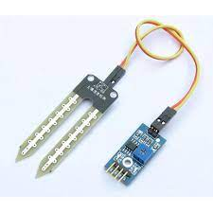

1. **BREAD BOARD**

It is a construction base used to build semi-permanent prototypes of electronic circuits.

1. **RAIN SENSOR**

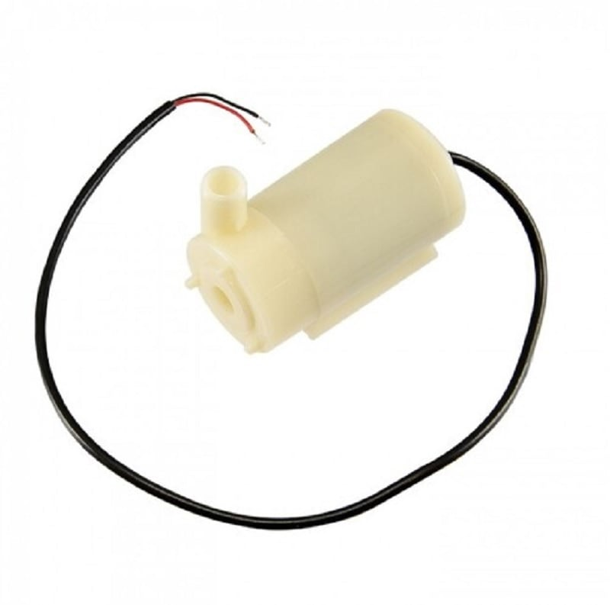A rain sensor is one kind of switching device which is used to detect the rainfall. It works like switch and the working principle of this sensor is, whenever there is rain, the switch will be normally closed. It uses an LM393 comparator with wide voltage.

1. **MOTOR PUMP**

A Motor pump is a mechanical device, used to move the liquids/gases from one place to another by using mechanical action. The working principle of the water pump is, it converts the motor's energy from mechanical to fluid flow.

1. **RELAY**

A relay is an electrically operated switch. It consists of a set of input terminals for single or multiple control signals, and a set of operating contact terminals.

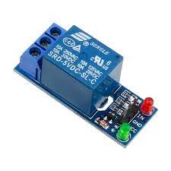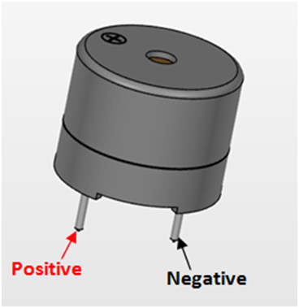

1. **BUZZER**

A buzzer or beeper is an audio signalling device, which may be mechanical, electromechanical, or piezoelectric (*piezo* for short). Typical uses of buzzers and beepers include alarm devices, timers, trains, and confirmation of user input such as a mouse click or keystroke.

## WORKING CIRCUIT

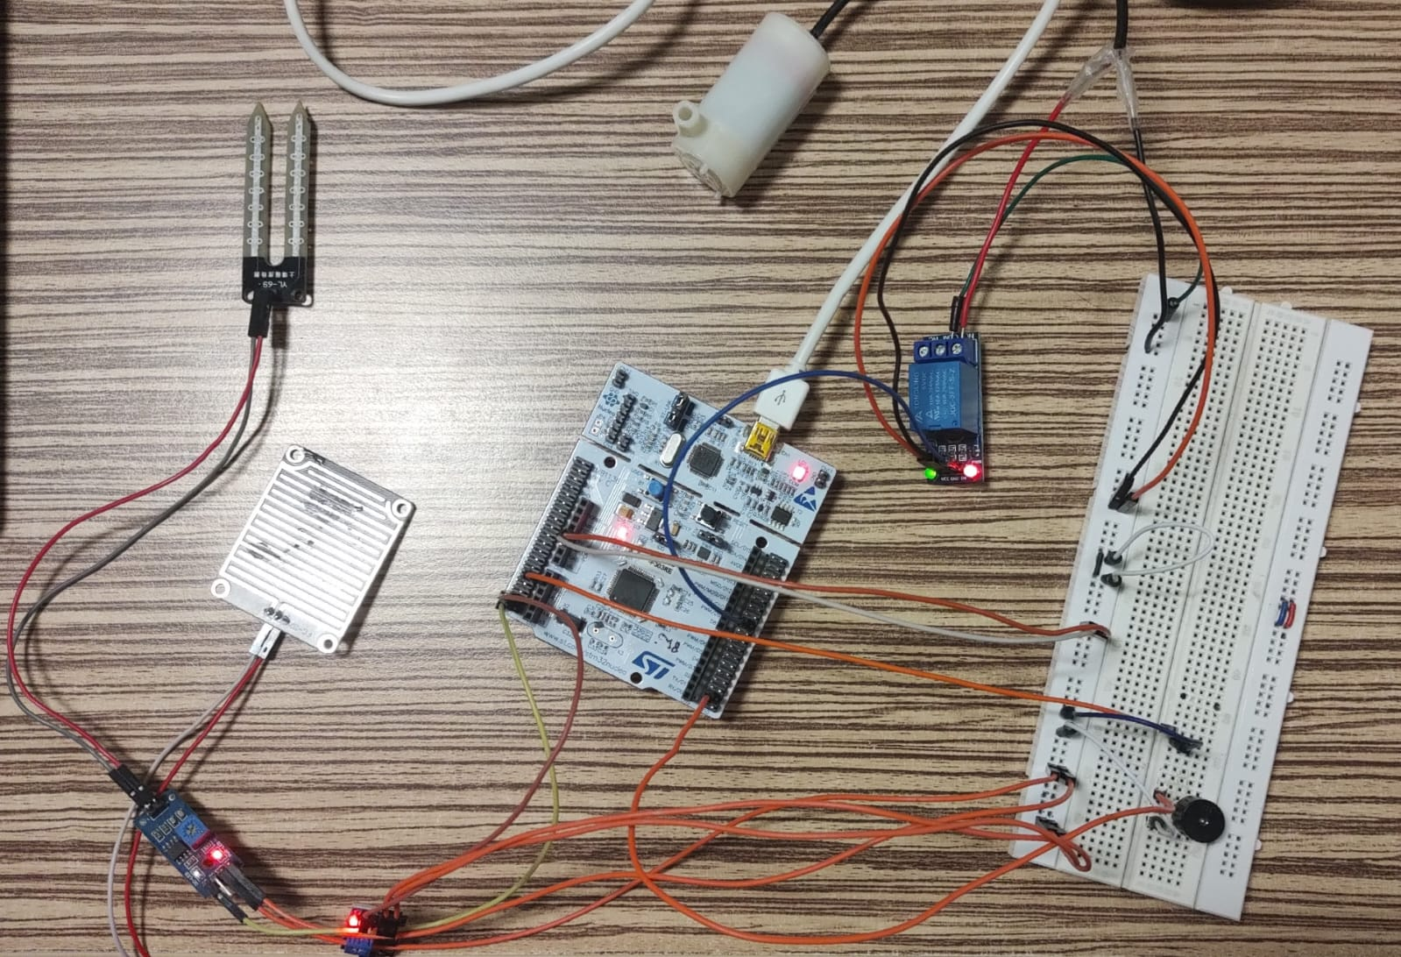

## SCHEMATIC

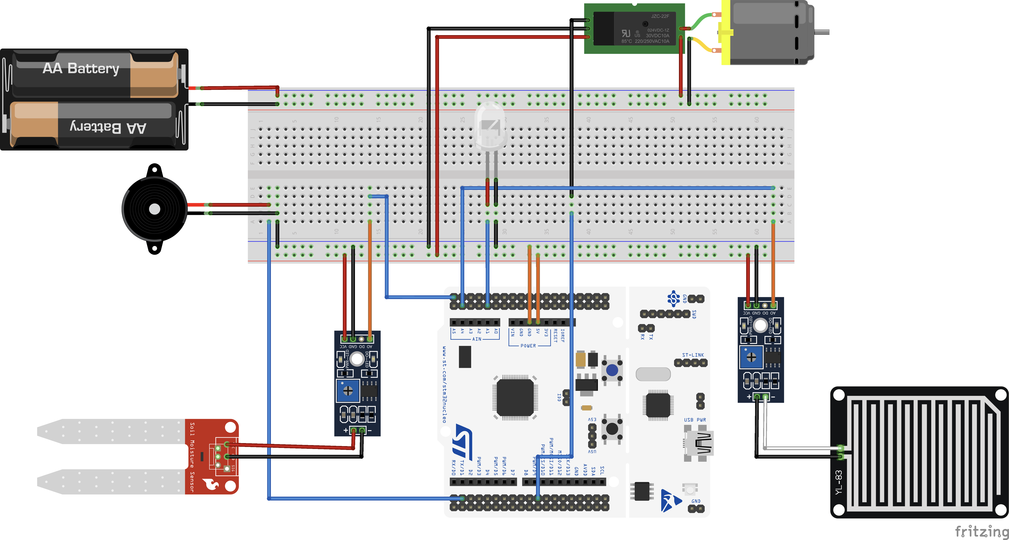

## 

## WORKING

Smart Drop is a project that is used to regulate moisture in an area to a regulated amount. This process is done by use of STM32F303RE board as microcontroller, rain sensor to find the moisture in the air, soil moisture sensor to find the moisture in the soil, Relay which acts as a switch for motor to open and close the gate use a dc power supply of 5v.

**How does Smart Drop work?**

Supplying power using Relay

Analog data from Soil Sensor

Analog data from Rain Sensor

We take one analog values from each sensor, and then we convert analog values into digital values using internal ADC. As the input is a 12-bit digital value, we divide it by 4095/100 to obtain a percentage value.

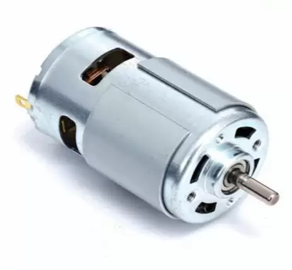

Let us assume the gate is closed at the start. First, both sensors check for moisture &rainfall in the area. Both sensors give an analogue value. This analogue value is converted into digital data of 12 bits using internal ADC & it is stored in microcontroller memory. There we observe that if the parameter *[(digital value/4096) *100]* of soil moisture is below 14% or the rain percentage is below 40%, the motor is turned off. Otherwise, the motor is turned on. (The limiting percentage values 14% and 40 are purely experimental & derived in our testing).

**When region is dry:**

|  |  |  |
| --- | --- | --- |
| **S. No** | **Name** | **Calculated Value = [(Digital Value)/4095] *100** |
| **1** | Soil moisture sensor | 10.60 |
| **2** | Rain sensor | 24.03 |

**When region is not dry, we have 3 cases:**

**When only soil is wet:**

|  |  |  |
| --- | --- | --- |
| **S. No** | **Name** | **Calculated Value = [(Digital Value)/4095] *100** |
| **1** | Soil moisture sensor | 16.32 |
| **2** | Rain sensor | 30.23 |

**When soil dry but starts raining:**

|  |  |  |
| --- | --- | --- |
| **S. No** | **Name** | **Calculated Value = [(Digital Value)/4095] *100** |
| **1** | Soil moisture sensor | 4.79 |
| **2** | Rain sensor | 58.38 |

**When it is both raining and soil is already wet:**

|  |  |  |
| --- | --- | --- |
| **S. No** | **Name** | **Calculated Value = [(Digital Value)/4095] *100** |
| **1** | Soil moisture sensor | 19.42 |
| **2** | Rain sensor | 55.67 |

## CODE

**FLOW OF CODE**

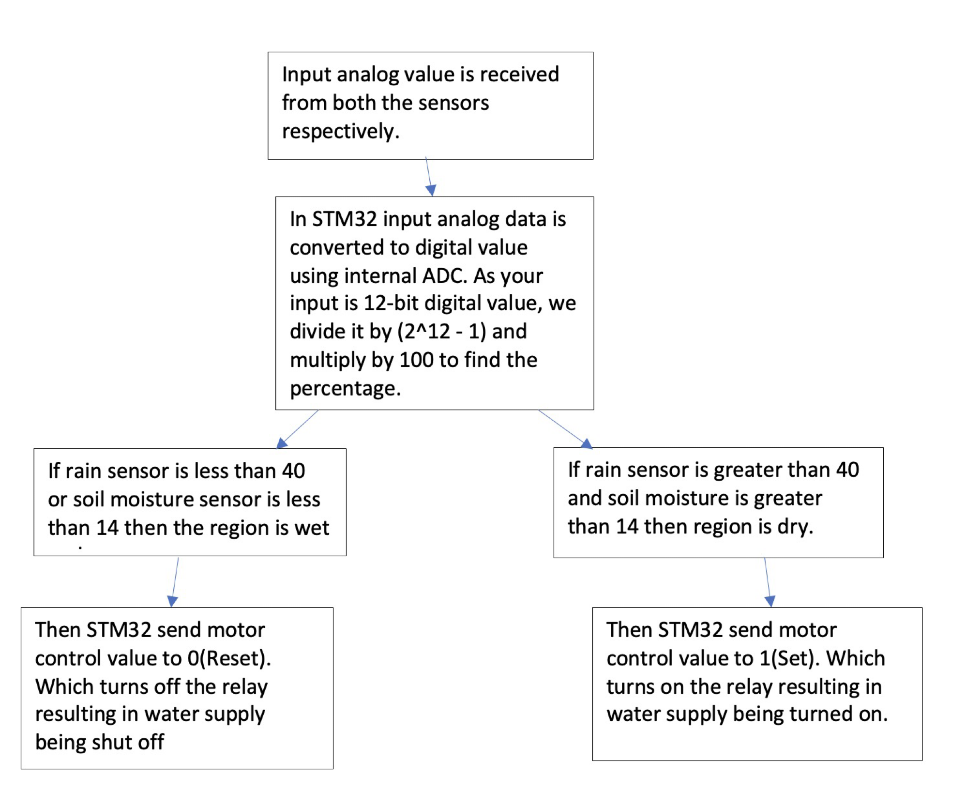

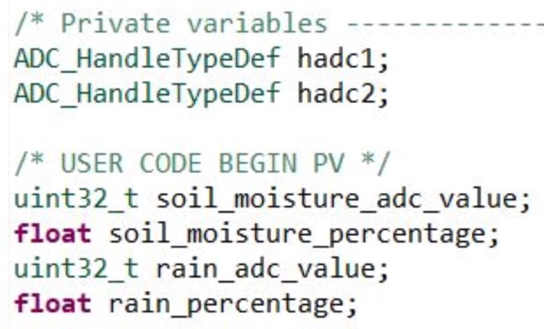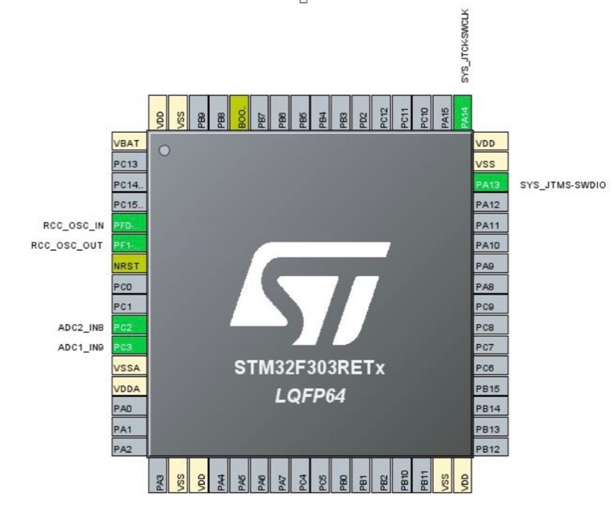**STM32CUBEIDE IOC PRIVATE VARIABLES**

**STM32CUBEIDE**

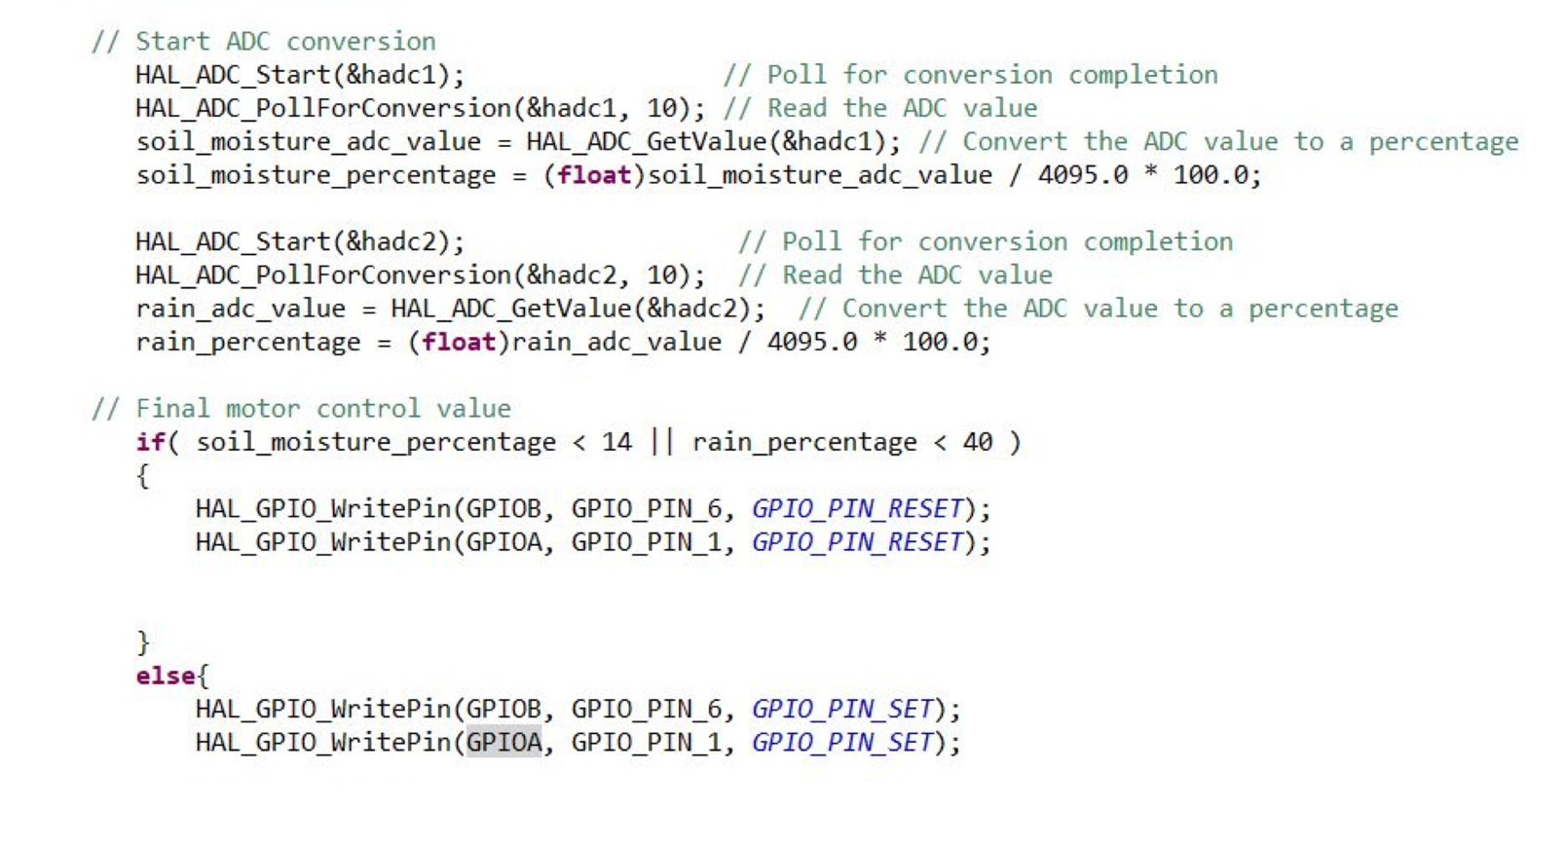

## 

## BENEFITS

Overall, the Smart Drop system is a cost-effective and efficient solution for regulating moisture levels in the soil, which offers several benefits to farmers, including reduced water usage, improved crop yield, and increased efficiency in agricultural practices.

1. **Reduced Water Usage:** The system controls the irrigation process based on real-time soil and weather conditions, which helps reduce water usage.
2. **Improved Crop Yield:** The system maintains the optimal moisture level in the soil, which helps improve crop yield.
3. **Increased Efficiency in Agricultural Practices:** The system is designed to be efficient and cost-effective, making it suitable for small and medium-sized farms.
4. **Wireless Communication:** The system uses wireless communication, which makes it suitable for large agricultural fields where wired connections are not feasible.
5. **Rain Sensor:** The system includes a rain sensor that predicts rainfall and adjusts the water flow accordingly, which saves water and reduces the risk of waterlogging in the soil.

## CHALLENGES

Interfacing with the LCD module was challenging due to pin configuration, compatibility issues, programming complexity, and wiring/connection issues. These challenges caused errors, malfunctioning, and incorrect information display. With proper planning, research, and troubleshooting techniques, these limitations can be overcome.

## 

## FUTURE ITERATIONS

In the future, the Smart Drop system can be improved by incorporating stepper motors to provide flexibility in changing the amount of water being released.

Additionally, the introduction of a Wi-Fi module can make the system more effective by relaying relevant information to a web server and allowing users to turn the motor on/off and receive relevant field data. While the LCD module could not be integrated due to issues, the use case for displaying information can be replaced by utilizing the web server and the Wi-Fi module. These improvements can greatly enhance the efficiency and functionality of the Smart Drop system.

## CONCLUSION

The Wireless Real-Time Soil Monitoring Irrigation System developed using STM32 microcontroller and sensors offers several benefits, including reduced water usage, improved crop yield, and increased efficiency in agricultural practices. The system successfully regulates moisture levels in the soil based on real-time weather and soil conditions.

Future iterations of the system can further improve its efficiency and functionality by incorporating stepper motors for greater flexibility in water release and introducing a Wi-Fi module to relay information to a web server and allow remote access to system controls and field data. The setbacks experienced during the development process, such as the challenges with integrating the LCD module, provide opportunities for learning and growth.

Overall, the Smart Drop system represents a cost-effective and efficient solution for regulating moisture levels in the soil, which can benefit small and medium-sized farms. With further advancements and improvements, this system can be an important tool for enhancing sustainable agricultural practices and supporting food security.

## 

## REFERENCES

1. STMicroelectronics: <https://www.st.com/en/microcontrollers-microprocessors/stm32-32-bit-arm-cortex-mcus.html>
2. DHT11/DHT22 Soil Moisture Sensor: <https://www.adafruit.com/product/4026>
3. Rain Sensor Module: <https://www.dfrobot.com/product-46.html>
4. Stepper Motor: <https://www.sparkfun.com/products/9238>